**Batch: A-3 Roll No.: 16010122104**

**Experiment No. 10**

**Grade: AA / AB / BB / BC / CC / CD /DD**

**Signature of the Staff In-charge with date**

|  |
| --- |
| **Title:** Apply edge detection operators on images |

**Objective:** To learn and understand the effects of edge detection operators on images using Matlab.

**Expected Outcome of Experiment:**

|  |  |
| --- | --- |
| **CO** | **Outcome** |
| **CO4** | Design & implement algorithms for digital image enhancement, segmentation & restoration. |

**Books/ Journals/ Websites referred:**

1. http://www.mathworks.com/support/
2. www.math.mtu.edu/~msgocken/intro/intro.html.
3. R. C.Gonsales R.E.Woods, “Digital Image Processing”, Second edition, Pearson Education
4. S.Jayaraman, S Esakkirajan, T Veerakumar “Digital Image Processing “Mc Graw Hill.
5. S.Sridhar,”Digital Image processing”, oxford university press, 1st edition."

**Pre Lab/ Prior Concepts:**

Edge detection operators, such as Roberts, Prewitt, and Sobel, are used in image processing to identify edges or boundaries between objects in an image.

- The Roberts operator uses a pair of 2x2 convolution masks to calculate the gradient approximation of the image intensity, detecting edges at 45-degree angles.

- The Prewitt operator uses two 3x3 convolution masks to calculate the gradient approximation, detecting edges in vertical and horizontal directions.

- The Sobel operator also uses two 3x3 convolution masks but with weighted coefficients, giving more emphasis to pixels closer to the center of the mask. This helps in reducing noise sensitivity compared to the Prewitt operator.

These operators are commonly used in edge detection algorithms to enhance features in images for various computer vision applications.

Edge detection operators are widely used in image processing and computer vision for various purposes, including:

1. Feature detection: Edges often correspond to changes in depth, color, texture, or illumination in an image, making them useful for detecting objects or boundaries of objects.
2. Image segmentation: Edges can help separate objects from the background by defining their boundaries, which is useful in tasks like object recognition and tracking.
3. Image enhancement: Edges can be enhanced or highlighted to improve the overall visual quality of an image or to emphasize specific features.
4. Image analysis: Edge detection is often a crucial step in analyzing images for specific patterns or structures, such as in medical imaging for detecting tumors or in industrial applications for quality control.
5. Image compression: Edges contain important information about the structure of an image and can be used to reduce the amount of data needed to represent it, leading to more efficient compression algorithms.

**Implementation Details:**

clc; clear; close all;

% Read image

img = imread('parrot.bmp');

if size(img, 3) == 3

img = 0.2989 * img(:, :, 1) + 0.5870 * img(:, :, 2) + 0.1140 * img(:, :, 3);

end

img = double(img);

[rows, cols] = size(img);

% Padding

padded_img = zeros(rows + 2, cols + 2);

padded_img(2:end-1, 2:end-1) = img;

padded_img(1, 2:end-1) = img(1, :);

padded_img(end, 2:end-1) = img(end, :);

padded_img(2:end-1, 1) = img(:, 1);

padded_img(2:end-1, end) = img(:, end);

padded_img(1, 1) = img(1, 1);

padded_img(1, end) = img(1, end);

padded_img(end, 1) = img(end, 1);

padded_img(end, end) = img(end, end);

% Masks

sobel_x = [-1 0 1; -2 0 2; -1 0 1];

sobel_y = [-1 -2 -1; 0 0 0; 1 2 1];

roberts_x = [1 0; 0 -1];

roberts_y = [0 1; -1 0];

% Initialize

grad_x = zeros(rows, cols);

grad_y = zeros(rows, cols);

grad_mag = zeros(rows, cols);

roberts_grad_x = zeros(rows, cols);

roberts_grad_y = zeros(rows, cols);

roberts_mag = zeros(rows, cols);

roberts_theta = zeros(rows, cols);

% Sobel Operator

for i = 2:rows+1

for j = 2:cols+1

region = padded_img(i-1:i+1, j-1:j+1);

sum_x = 0;

sum_y = 0;

for m = 1:3

for n = 1:3

sum_x = sum_x + region(m, n) * sobel_x(m, n);

sum_y = sum_y + region(m, n) * sobel_y(m, n);

end

end

grad_x(i-1, j-1) = sum_x;

grad_y(i-1, j-1) = sum_y;

end

end

% Roberts Operator

for i = 1:rows-1

for j = 1:cols-1

roberts_grad_x(i, j) = img(i, j) * roberts_x(1,1) + img(i, j+1) * roberts_x(1,2) + ...

img(i+1, j) * roberts_x(2,1) + img(i+1, j+1) * roberts_x(2,2);

roberts_grad_y(i, j) = img(i, j) * roberts_y(1,1) + img(i, j+1) * roberts_y(1,2) + ...

img(i+1, j) * roberts_y(2,1) + img(i+1, j+1) * roberts_y(2,2);

end

end

% Gradient Magnitude and Direction

for i = 1:rows

for j = 1:cols

grad_mag(i, j) = sqrt(grad_x(i, j)^2 + grad_y(i, j)^2);

roberts_mag(i, j) = abs(roberts_grad_x(i, j)) + abs(roberts_grad_y(i, j));

roberts_theta(i, j) = atan(roberts_grad_y(i, j) / roberts_grad_x(i, j)) - (3 * pi / 4);

end

end

% Normalize

max_val = max(grad_mag(:));

max_val_roberts = max(roberts_mag(:));

for i = 1:rows

for j = 1:cols

grad_mag(i, j) = (grad_mag(i, j) / max_val) * 255;

roberts_mag(i, j) = (roberts_mag(i, j) / max_val_roberts) * 255;

end

end

% Convert to uint8

grad_mag = uint8(grad_mag);

roberts_mag = uint8(roberts_mag);

grad_x = uint8(abs(grad_x));

roberts_grad_x = uint8(abs(roberts_grad_x));

% Display

figure;

subplot(2, 3, 1);

imshow(uint8(img)), title('Original Image');

subplot(2, 3, 2);

imshow(grad_x), title('Sobel X');

subplot(2, 3, 3);

imshow(grad_mag), title('Sobel Gradient Magnitude');

subplot(2, 3, 4);

imshow(roberts_grad_x), title('Roberts X');

subplot(2, 3, 5);

imshow(uint8(abs(roberts_grad_y))), title('Roberts Y');

subplot(2, 3, 6);

imshow(roberts_mag), title('Roberts Gradient Magnitude');

**Output:**

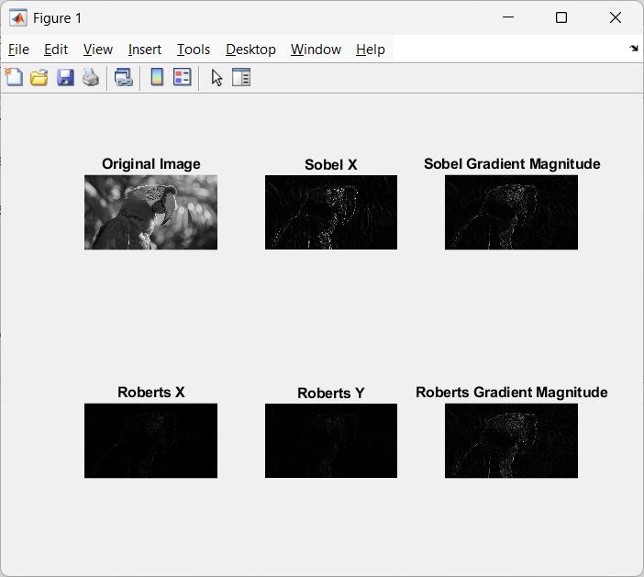

**Write Algorithm and Matlab commands used:**

**img = imread('numberplate.jpg');**

**kernel = [1,1,-1,-1];**

**filtered_img = imfilter(img, kernel);**

**kernel2 = [0,1,1,-1,0,1,-1,-1,0];**

**filtered_img2 = imfilter(img, kernel2);**

**kernel3 = [0,1,2,-1,0,1,-2,-1,0];**

**filtered_img3 = imfilter(img, kernel3);**

**% Display the original and filtered images**

**subplot(2, 3 , 1);**

**imshow(img);**

**title('Original Image');**

**subplot(2,3, 2);**

**imshow(filtered_img);**

**title('Robert Image');**

**subplot(2, 3, 3);**

**imshow(filtered_img2);**

**title('Prewitt Image');**

**subplot(2, 3, 5);**

**imshow(filtered_img3);**

**title('Sobel Image');**

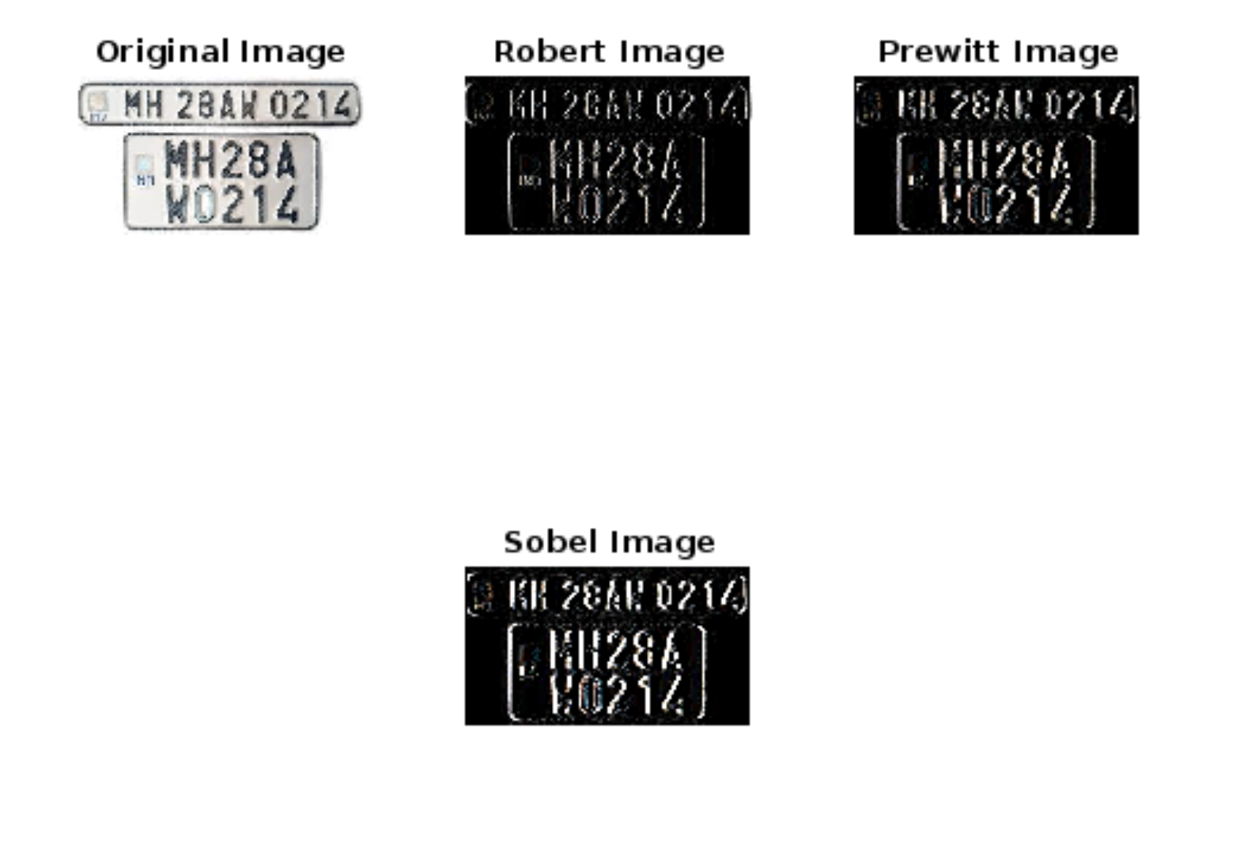

**Conclusion:-** Thus we have implemented Robert, sobel and Prewitt edge detection operators in matlab. These operators are useful for detection of edges of an image. In this case, we have used them to detect edges of a numberplate. Edge detection operators play a fundamental role in many image processing tasks by providing valuable information about the structure and content of images.